**DT282 Software for the Global Market 2**

**Phase II**

**Note: You can change the look and feel of this document (fonts, section order, adding sub-sections etc. but you must address all the requirements for content).**

# Group Number:

# Group Members:

|  |  |
| --- | --- |
| **Student Number** | **Student Name** |
| C18416902 | Ire Adebari |
| C18333703 | Nikolay Malyshev |
| C18359123 | Raphael Ofeimu |
| C18420686 | Kyle Butler |
| C18357323 | Daniel Krasovski |

# Introduction

***Societies and Events***

# Personas

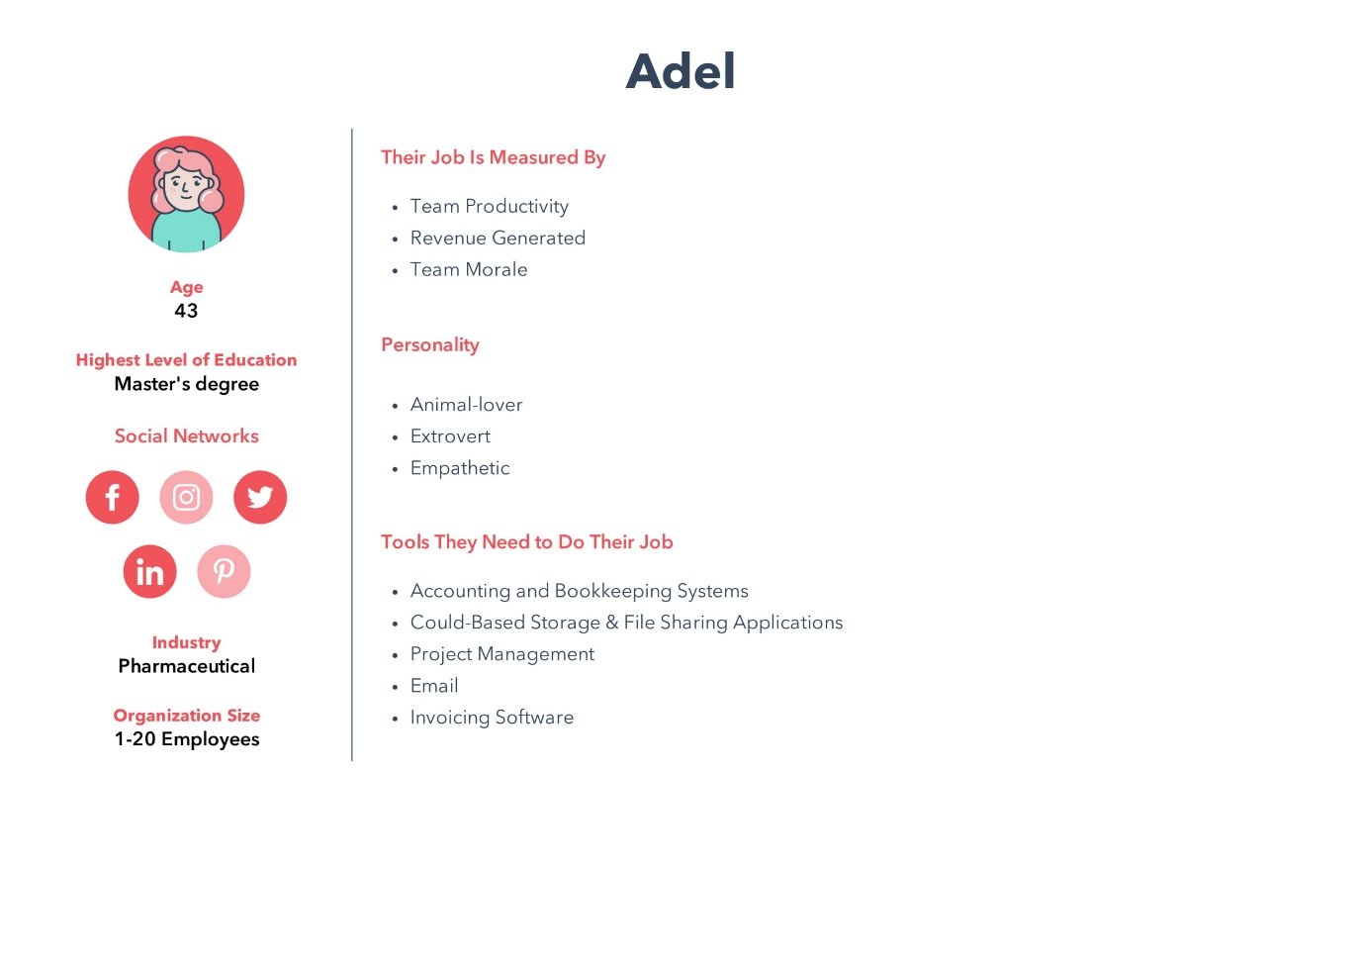

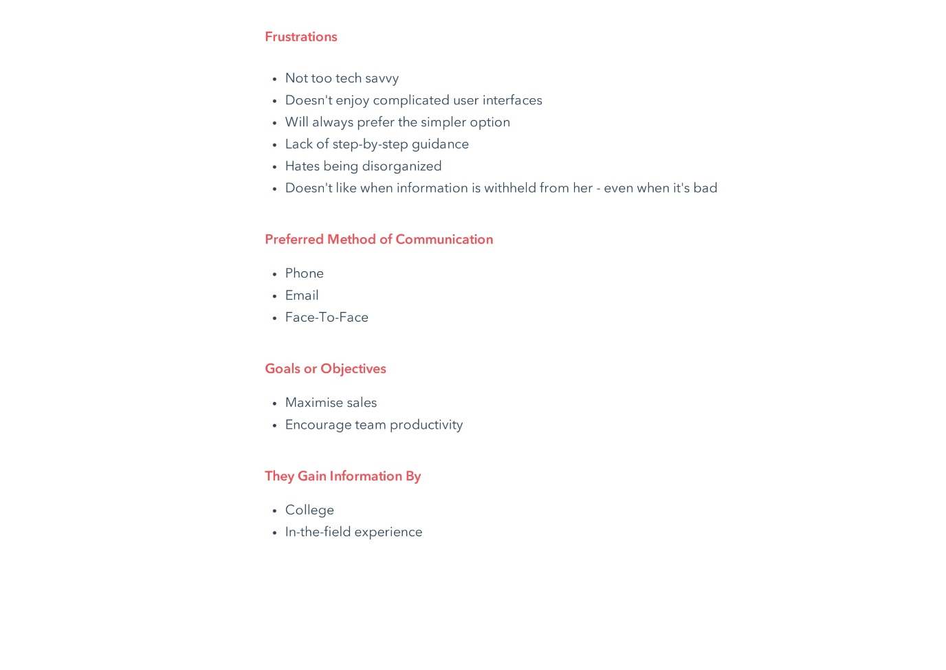

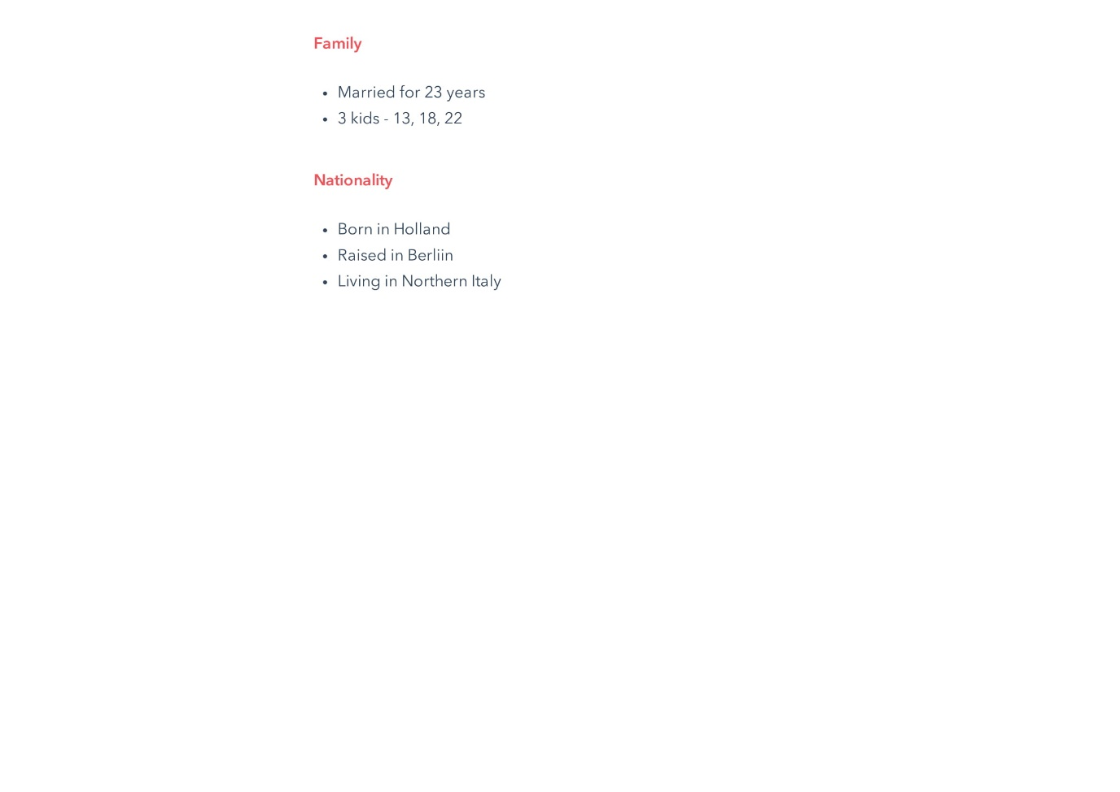

***When we were addressing the cultural dimension of Monochronic Vs. Polychronic, we mentioned an attribute in every persona that relates to this particular dimension. In Adel’s case, we described her as quite one-track minded, with a natural veering towards a more simplistic approach. In terms of the Universalism Vs. Particularism dimension, Adel evidently has a more particular approach to life, seeing as she has travelled to various places around the world. This enables her to be much more understanding in terms of different ideas and practices.***

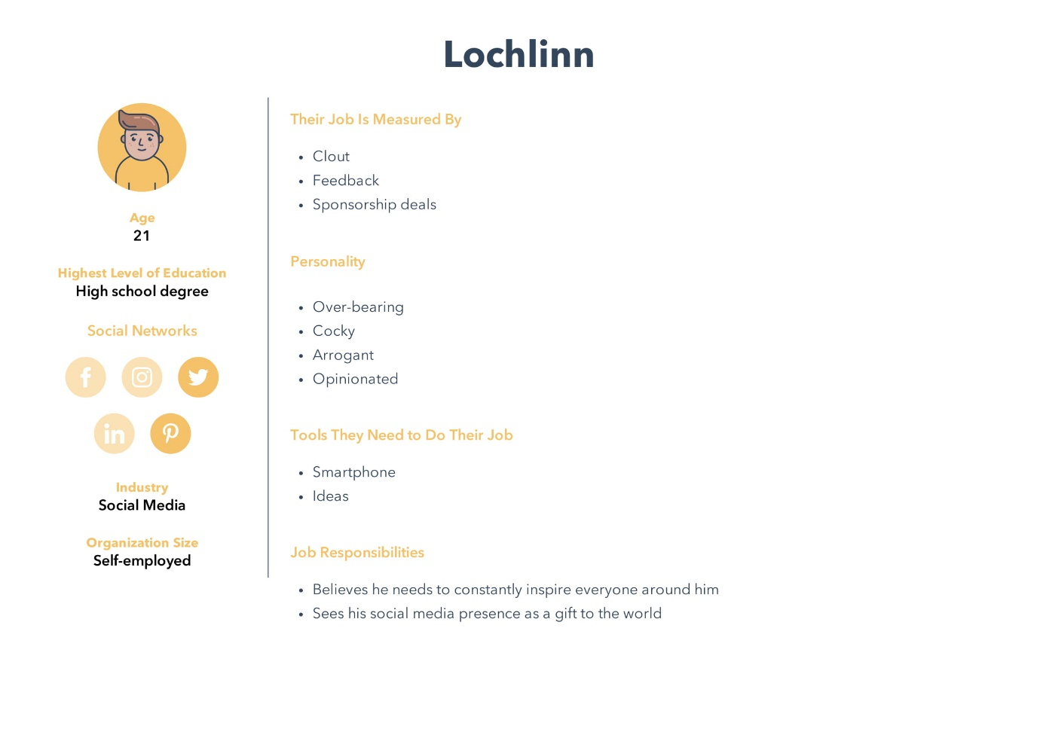

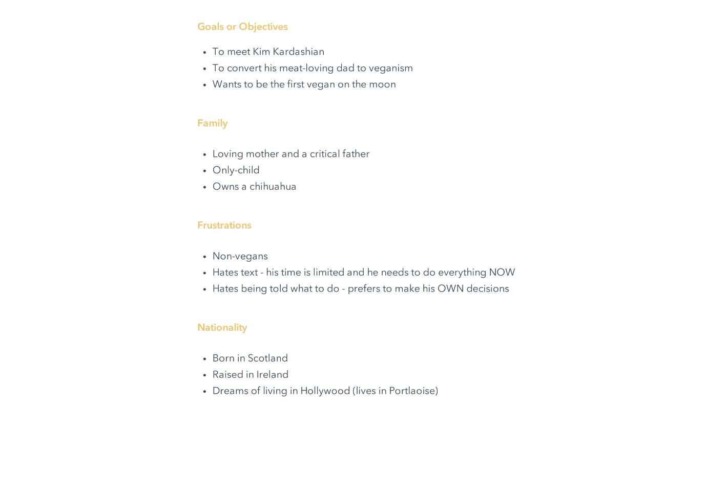

***When we were addressing the cultural dimension of Monochronic Vs. Polychronic with this persona, we mentioned how Lochlinn wants to do everything right now, as fast as possible (thus giving him a polychronic mentality). Due to his mindset on peoples’ perspective on him, we would definitely classify this persona to be quite universalistic. He thinks that his beliefs and opinions should be universally accepted by everyone, which is what gives him this characteristic.***

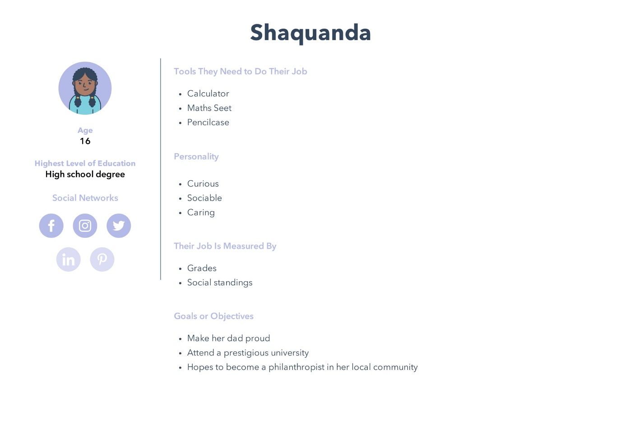

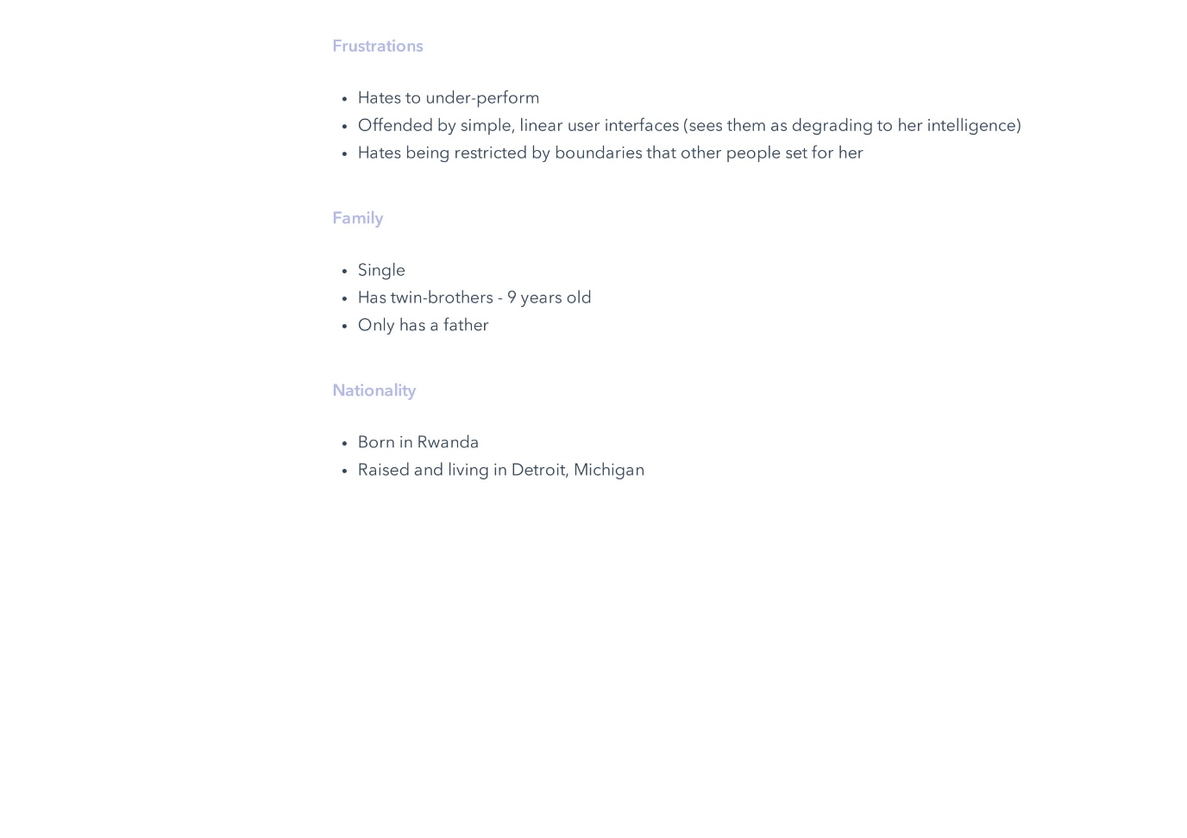

***In Shaquanda’s case, we decided to describe her as an outgoing, and understanding individual, who is highly intelligent and capable of performing well under pressure. With characteristics like these, she is deemed to have a particular mindset with polychronic tendencies. She is empathetic with a deep understanding of uniqueness and difference, while also being engaged and interested through more complex systems.***

# Hypotheses

***As a group, we have decided to create a website based on Events and Societies in TUDublin, with a large emphasis on the cultural dimensions of Monochronic Vs. Polychronic, and Universalism Vs. Particularism. We thought we’d explore variations of the layout of the website that could apply to our chosen cultural dimensions.***

***For example, a linear, call-and-answer type of design that very clearly guides the user through whatever task they are trying to accomplish. We believe that doing this for Adel, will achieve ease of accessibility through the website and a sense of achievement on her part.***

***Other ideas involved a much more explorer-oriented approach, where the user is given a lot more information to complete desired tasks. We believe that doing this for Shaquanda will allow her to use our website comfortably with a sense of control. She can delve deeper into the website and how she accesses it. This approach is far less hand-holding, giving the user a lot more freedom in terms of navigating through our website.***

# Wireframe(s)

***We used Adobe XD to create our wireframes.***

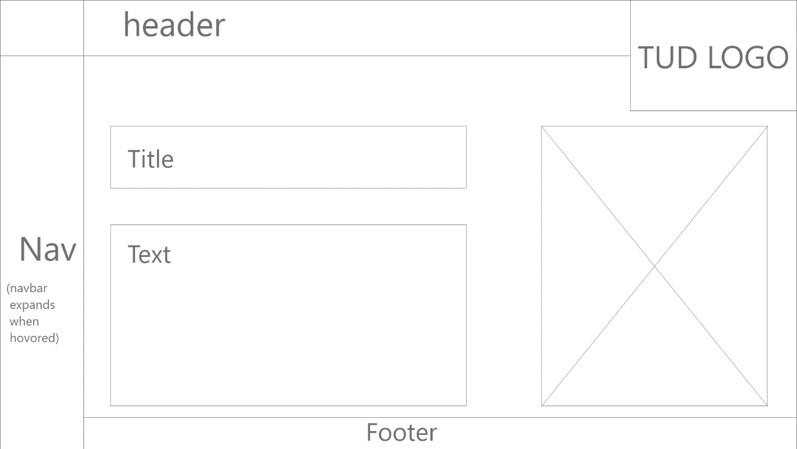

***With a design like the above wireframe, we believe the expanding navbar along with the image pushed to the side rather than the centre, quite evidently accommodates a monochronic mindset. While not overbearing the user with information, we are trying to guide the user and not bombard them with information. We would make the navbar initially hidden so that the user won’t feel pressured into moving from webpage to webpage. This feature would inadvertently give the user a sense of control. With a wireframe like the above example, a persona like Shaquanda would find this design aspect very appealing.***

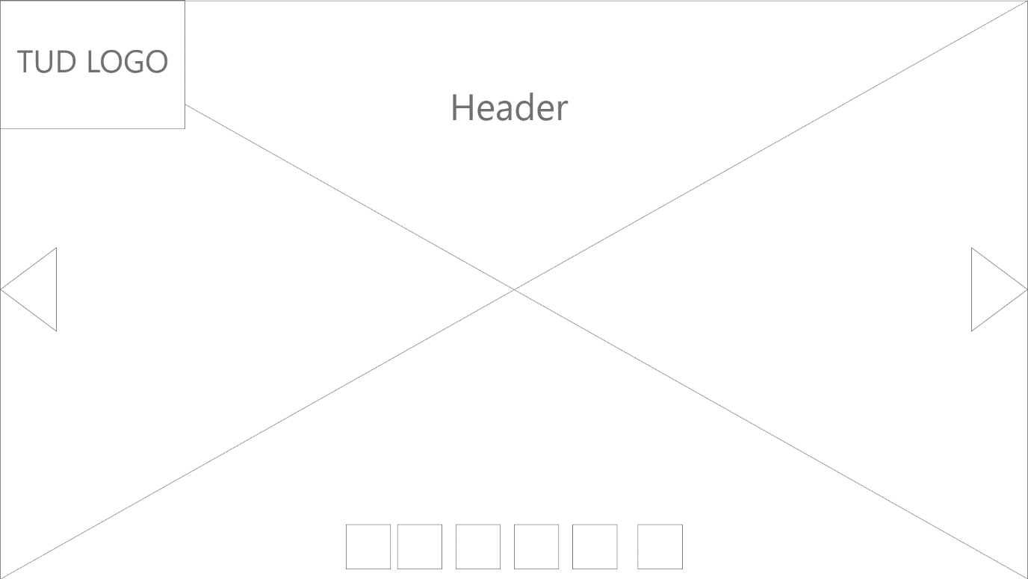

***With a design like this one, we are forcing the user to be much more creative and curious about how they wish to navigate through the website. The pictures are displayed in a carousel manner, and the navbar isn’t in plain sight so the user has to be responsive and inquisitive in order to maximise efficiency when navigating through a website like this. Here we would assume the user has a polychronic mindset due to how much this design relies on the users intuition. A design like this would cater to Lochlinn’s mindset, seeing as he wants to do everything at one any given time.***

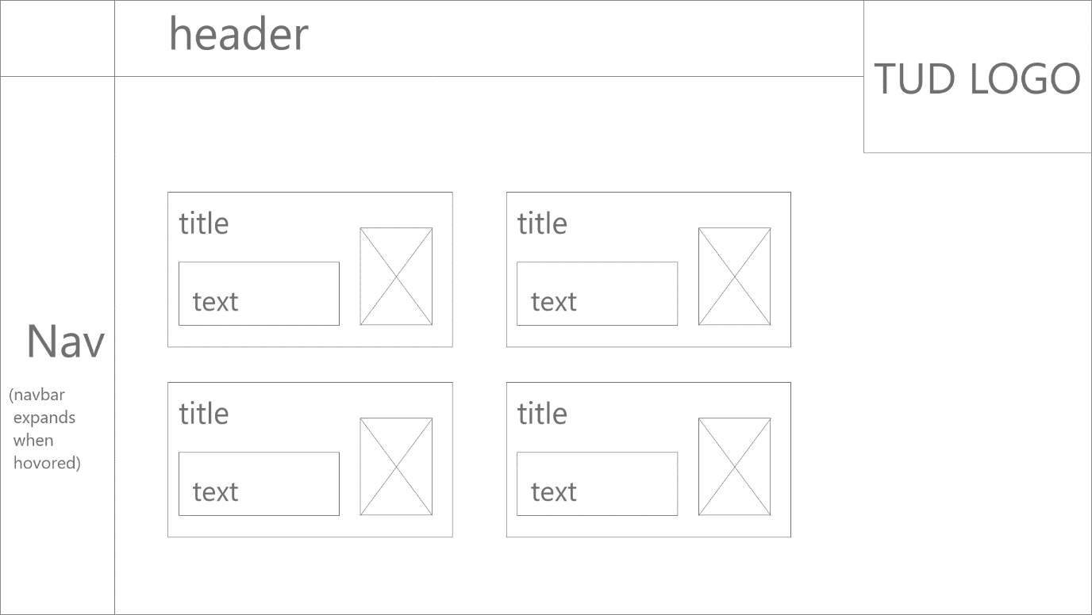

***Here, we are displaying quite an amount of information on the screen at one time. Images, a disappearing navbar, and text are all displayed at any given moment on this type of layout. Due to how much information this design gives the user, we would also classify this layout as polychronic, with undertones of universalism. The reason is because of the amount of information we so boldly display at one time, this is perhaps assumptive on our end it terms of how we expect the user to portray our website. We expect the user to have very strong beliefs in a website’s layout, so for that reason, a design like this would cater towards the universalistic mindset. This design layout is great for Lochlinn, due to his lack of patience.***